DFD level 0
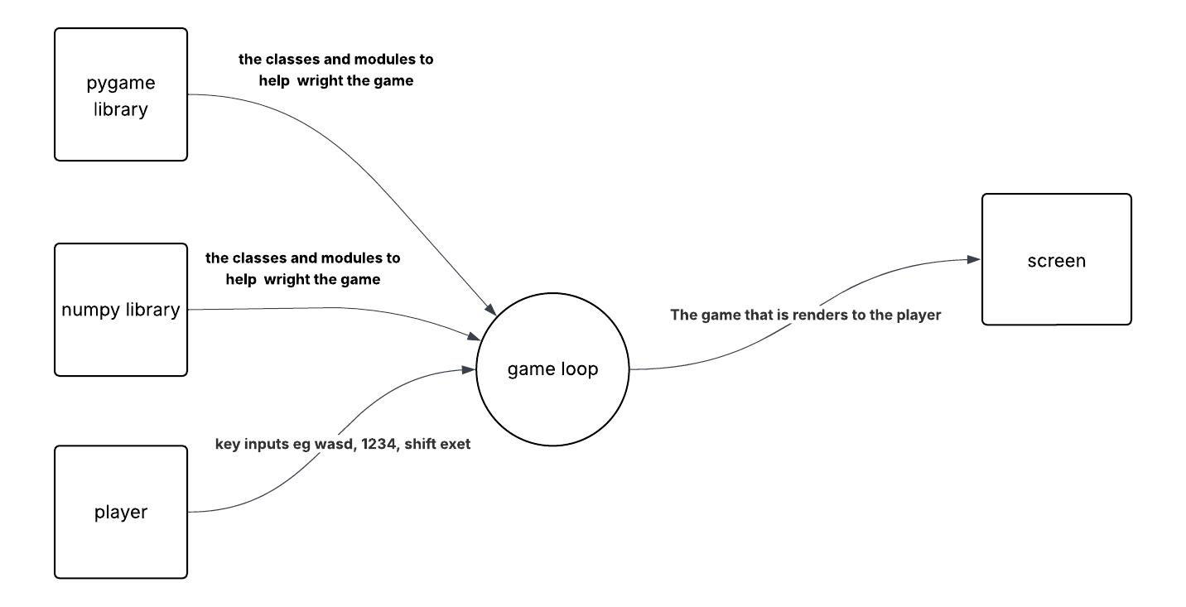
If you can’t see the image there is a picture in my submission folder and below my lucid chart share link:
https://lucid.app/lucidchart/242b657f-ce41-40db-8973-1c0339151cd4/edit?view_items=ee5rOw~MM7Kc%2CU44r1o.0Ol.-%2CB44rd~hkTGOl%2CU74rXrc_5A0T%2CMd5rJ-Vw4tuo%2C_94rGtncJzK8%2C9~4rzJUGzfiS%2Cpd5rX_z2z5nf%2C844ryxBX_bW9%2CT74r1pB~0md8%2Cxd5r57rPtoFL&invitationId=inv_16470804-7fb9-42f7-ac62-f5c45fdf3d89

DFD level 1
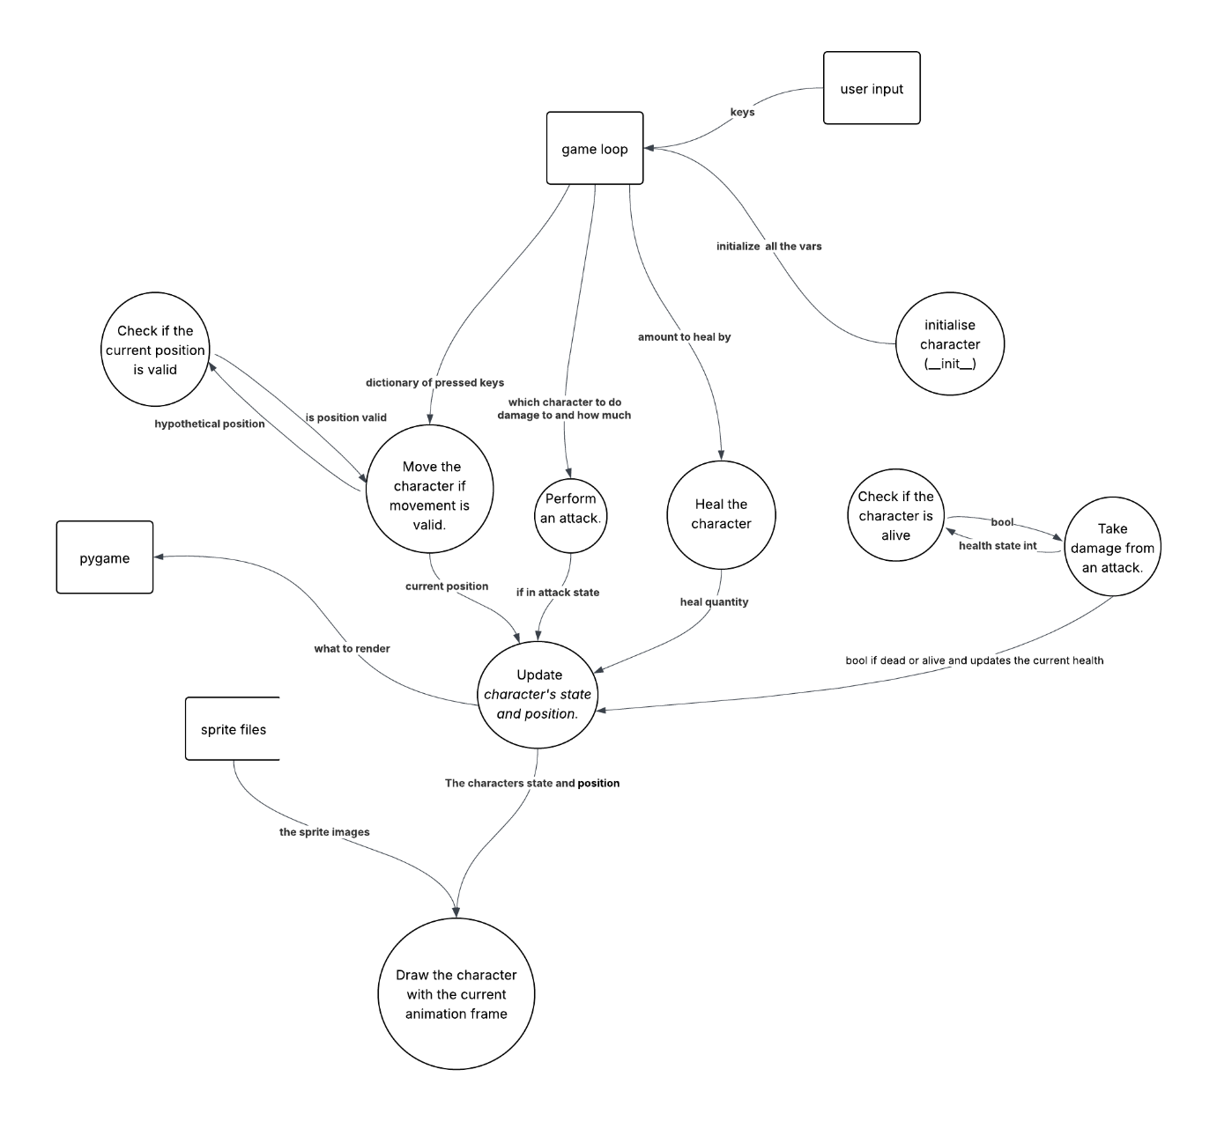

If you can’t see the image there is a picture in my submission folder and below my lucid chart share link:
https://lucid.app/lucidchart/5a848b15-c2e6-4cd7-b02d-1f7292cbbc78/edit?viewport_loc=978%2C-1001%2C2272%2C1322%2C0_0&invitationId=inv_a0f34aa7-e975-42f1-b16a-8923b873997b

Class diagram
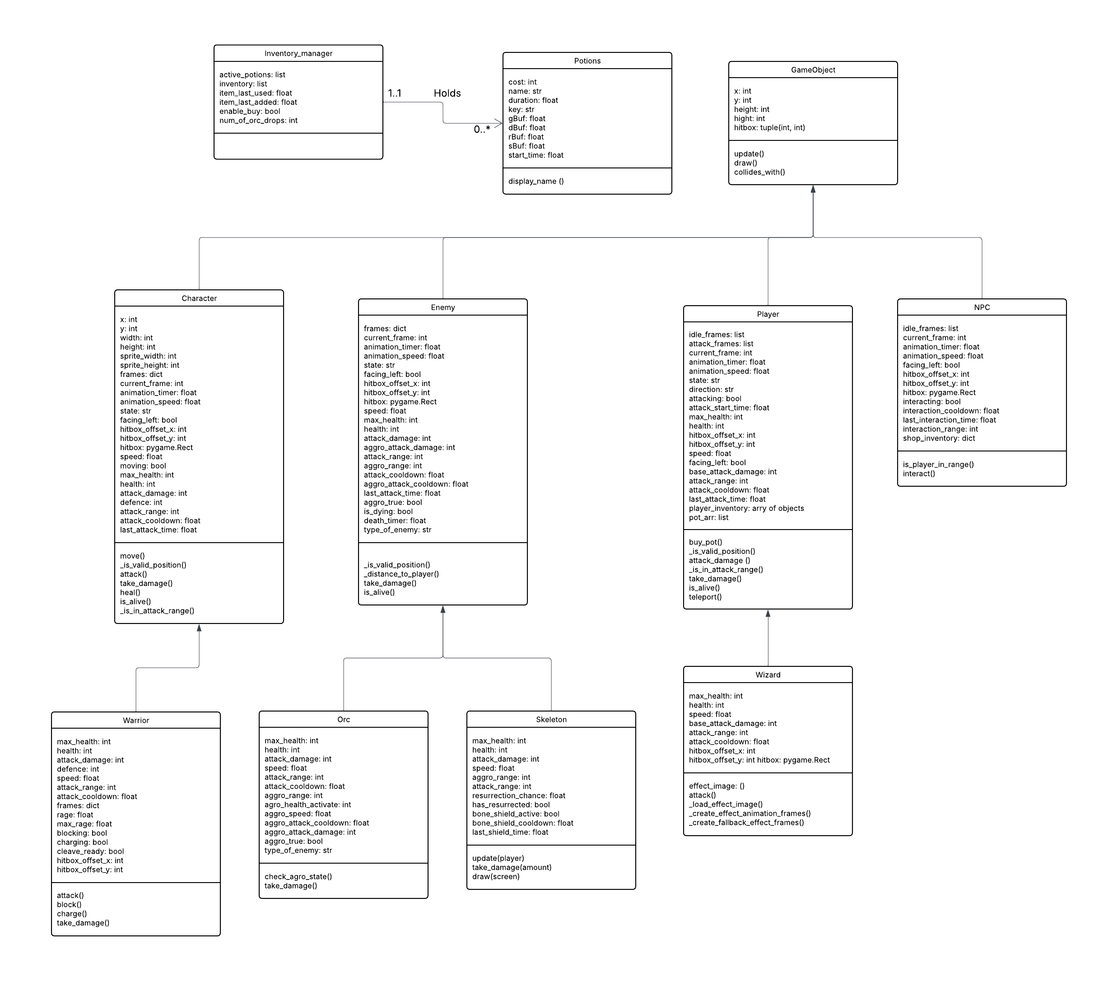
If you can’t see the image there is a picture in my submission folder and below my lucid chart share link:
https://lucid.app/lucidchart/c97864cc-da5f-442d-b9e8-f16bd5718434/edit?view_items=xsQrT.cy3~PE%2CFsQrn_fhXxsO%2CgRQrKE1.oTfB%2CKSQrtN6K2TPN%2CcTQrXQOjd5Nd%2CwTQrAIiL-X8x%2CxTQr~oz5OsNU%2CxTQrZO6Wuty3%2CT3QrFbkYIsVY%2C73QrpY.a76V5%2C73QryGKVOobJ%2CAE9r9hagavtU%2CqF9rcKLZZw-t%2CHH9r6~8Ceilx%2C3H9rwevqtcJn%2CaI9r~6Pg0PTs%2CTI9rGR0DIQhj%2CRJ9rQunvOnpM%2C7J9rHUS_6Oyj%2C1HqsJMvP3xy.%2CoIqsJ3TKJijx%2CSIqsymhqzRWu%2CjKqs4saTeKdF&invitationId=inv_6081b6eb-fd51-4a22-9f45-aa385315285b

Gann chart
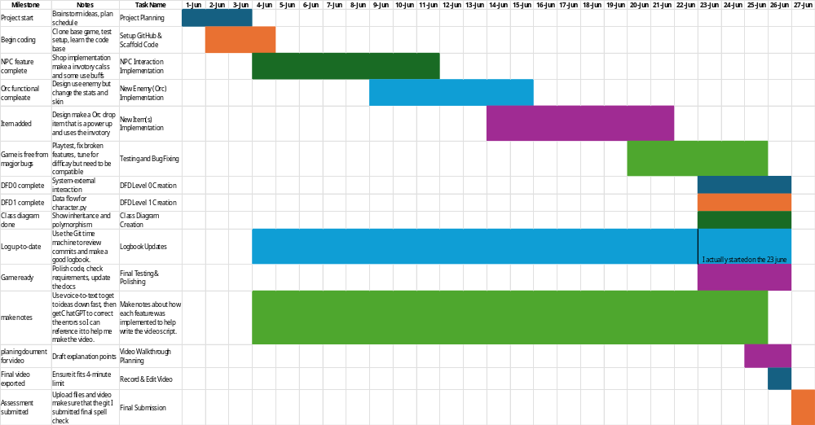

Log book

Date: | 04/06/2025
Title: | Change the default number of potions
Author: | Freddy Gaffey
Tasks description: | Adjust the number of potions to a desired amount and tested this also helps change gameplay.
Image of the code changed: | 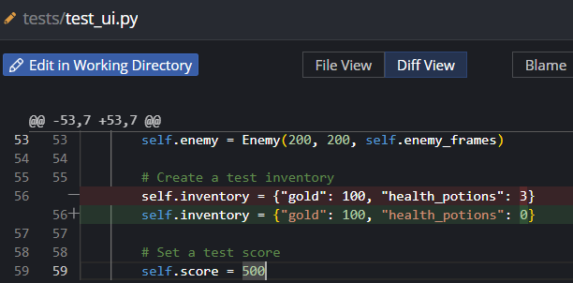  The commit: cb17bb7f8a6cb2ad6933e5cb4ef6c10f2c4f9c52
Logbook entry: | - Progress since the last entry:  Gained a better understanding of how the inventory is implemented in this game.  - Tasks achieved:  Changed the default number of potions  - Stumbling blocks or issues encountered and how they were managed:  I found how the inventory was written slightly confusing so this is why I chose to make an inventory with its own class to help make it easier to write while keeping the existing gold and health potions the same.  - Possible approaches for upcoming tasks:  See above  - Reflective comments:  I think it’s essential to start earlier, so that my understanding of the code structure develops earlier. I had made a lot of assumptions that led me to develop approaches that were ultimately not successful.  - Resources used:  Kraken desktop for viewing the diffs  Vs code as my IDE  Find (ctrl + F)  Vs code’s linter for help following the code base

Date: | 12/06/2025
Title: | Fix animations
Author: | Freddy Gaffey
Tasks description: | Resolved two bugs one where the enemy dies in the animation does not work properly.
Tasks achieved | - adjust the wizard frame to be correct the comments above this fixes the glitch when the wizard attacks  - make the enemy animation die properly
Image of the code changed: | 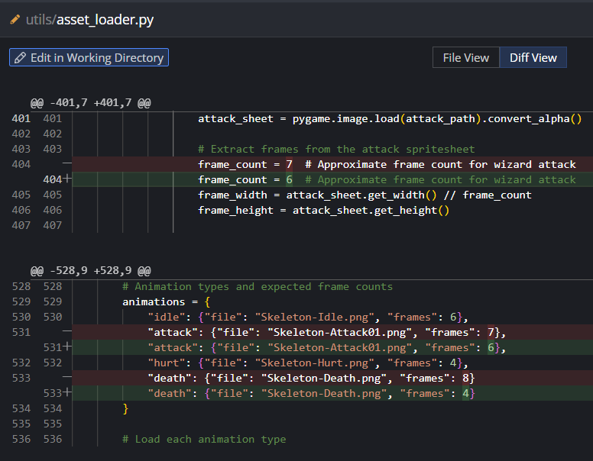  The commit f17c43cec2d99066426e43f7a5912f27aeae4891  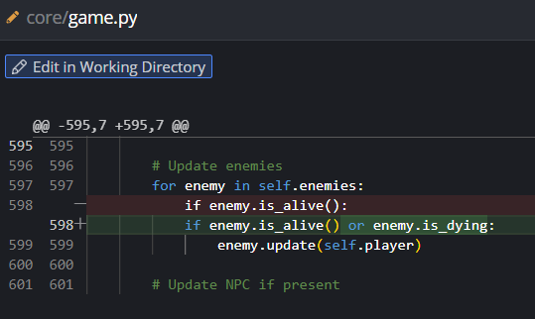  The commit 9d6d8d098925856e69ceab9e4615b6b7c9c764e2

Logbook entry: | - Progress since the last entry:  Applied two minor bug fixes as well as gaining a deeper understanding of how the animations work.  - Tasks achieved:  • adjust the wizard frame to be correct the comments above this fixes the glitch when the wizard attacks  • Make the enemy animation die properly  - Stumbling blocks or issues encountered and how they were managed:  It took me a while to find this bug because it was simply changing a number in a dictionary and adding a check to an ‘if statement’ because these things are easily overlooked and I assumed they were done correctly initially.  - Possible approaches for upcoming tasks:  I need to create an item and because of the difficulty in understanding and working with the existing inventory structure for what I want to implement. I will create a class containing an inventory and a separate class for a potion and then I will use a dictionary of buffs. I can adjust the speed damage resistance and to multiply when you pick up with gold.  - Reflective comments:  I should have paid closer attention to the specifics of how it was implemented and double checked everything as opposed to assuming it was done correctly this would have saved a lot of time.  - Resources used:  Kraken desktop for viewing the diffs  Vs code as my IDE  Find (ctrl + F)  Vs code’s linter for help following the code base

Date: |  | 12/06/2025
Title: |  | create and test the inventory class
Author: |  | Freddy Gaffey
Tasks description: | The inventory class is created and tested also the potions class was created and tested as a sub item in the item in the inventory class.
mage of the code changed: |  | """  this file contains constants the related constants for the inventory  items and their effects  """  import time  # from abc import abstractclassmethod  # from ui.ui import UI  # from player import Player  # from core.game_object import gameobject  # Inventory item constants  # health_potions = {"cost": 40,"sell": 40, "effect": "Restores 20 HP"}  # mana_potions = {"cost": 30, "effect": "Restores 15 MP"} # decreased cool down  # speed_potions = {"cost" : 29, "effect": "Increases speed by 20% for 10 seconds"}  # double_damage_potion = {"cost": 100, "effect": "Doubles damage for 30 seconds"}  # gold_multiplier = {"cost": 50, "effect": "Increases gold gain by 50% for 5 minutes"}  # class potions(gameobject):  class potions():  """  this is the parent class to make the potions  the potion stores duration, potion start time, as well as buff multipliers  (1.0 is no buff)  these buffs can be any float and change the effect of pickups/damage/etc.  """  cost = None  name = None  quantity = None  start_time = None  duration = None  gBuf = None  dBuf = None  rBuf = None  sBuf = None  def __init__(self,cost,name,duration,rBuf=1,sBuf=1,dBuf=1,gBuf=1):  self.cost = cost  self.name = name  self.start_time = None  self.sBuf = sBuf  self.dBuf = dBuf  self.rBuf = rBuf  self.gBuf = gBuf  self.duration = duration  class Inventory_manager():  """this class manages the item in a inventory it is applicable for  both the player and the npc  """  active_potions = []  inventory = []  def __init__(self):  pass  def add_item(self,item):  self.inventory.append(item)  def activate(self,pot_name):  for pot in self.inventory:  if pot_name == pot:  self.active_potions.append(pot)  self.inventory.remove(pot)  pot.start_time = time.time()  def add_to_inventory(self,pot):  self.inventory.append(pot)  def get_active_potion_and_buf(self):  """  this functon will return a dict of the types of potions and there  multipliers  """  buffs = {  "gold":1,  "resistance":1,  "damage":1,  "speed":1}  for pot in self.active_potions:  if pot.start_time + pot.duration < time.time() or pot.duration == 0:  buffs['gold'] *= pot.gBuf  buffs['resistance'] *= pot.rBuf  buffs['damage'] *= pot.dBuf  buffs['speed'] *= pot.sBuf  self.active_potions.remove(pot)  else:  buffs['gold'] *= pot.gBuf  buffs['resistance'] *= pot.rBuf  buffs['damage'] *= pot.dBuf  buffs['speed'] *= pot.sBuf  return buffs  r_pot = potions(10,"h_pots",10,rBuf= 3)  player_inventory = Inventory_manager()  player_inventory.add_item(r_pot)  player_inventory.activate(r_pot)  while True:  print(player_inventory.get_active_potion_and_buf())  # def get_active_potion_and_buf(self):  # """  # this functon will return a dict of the types of potions and there  multipliers  # """  # temp = {  # "gold":1,  # "resistance":1,  # "damage":1,  # "speed":1}  # for pot in self.active_potions:  # if self.start_time + self.duration < time.time():  # self.active_potions.remove(pot)  # else:  # temp['gold'] *= pot.gBuff  # temp['resistance'] *= pot.rBuff  # temp['damage'] *= pot.dBuff  # temp['speed'] *= pot.sBuff  # class health_potions(potions):  # """ this is the health potion class that inherits from potions  # """  # def __init__(self, cost, name):  # super().__init__(cost, name)  # amount_health_gain = 30  # # give the player more health  # def use_potion():  # def check_potion_use(self, player: Player, ui: UI):  # # example in game/Game line 739  # # def check_health_potion_use(self):  # # """Check for health potion use."""  # # keys = pygame.key.get_pressed()  # # if (keys[pygame.K_h] and  # # self.inventory["health_potions"] > 0 and  # # self.player.health < self.player.max_health):  # # # Use a health potion  # # healing = min(30, self.player.max_health - self.player.health)  # # self.player.health += healing  # # self.inventory["health_potions"] -= 1  # # self.ui.set_message(f"Used a health potion.  Healed for {healing} health!")  The commit: f7d055098bc00b8bc2ef6fd53f4cbbcbb4d40818  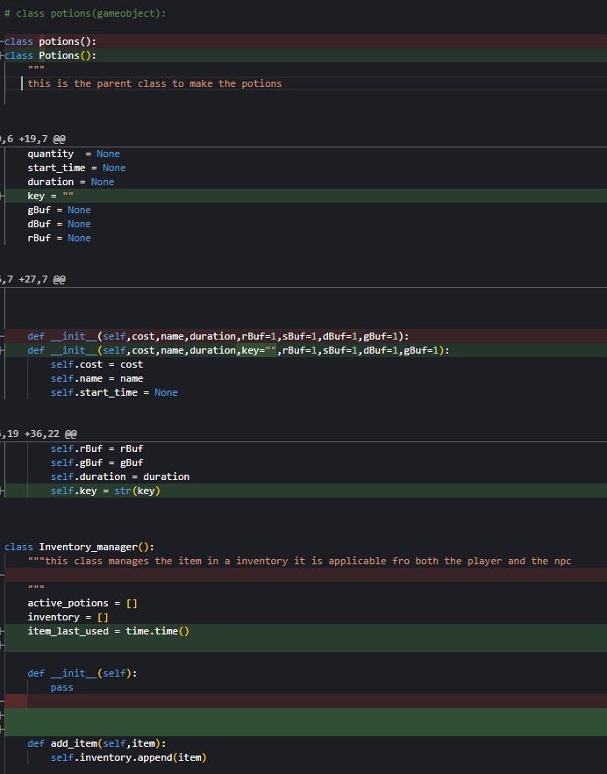
 |  | Commit: 923394ffb153b1d644e78b89fcd927b00b1f28e4

Logbook entry: | - Progress since the last entry:  I have successfully implemented a potions class and an inventory class, which means I'm coming ever closer towards being able to successfully implement a game item.  - Tasks achieved:  I have made the potions class and the inventory class with the associated methods for controlling potions in the inventory and getting the buffs. Then in a second commit I adapted the file to follow the appropriate nomenclature culture.  - Stumbling blocks or issues encountered and how they were managed:  I had some stumbling blocks getting the mechanics of the dictionary updating properly so that is why I wrote the test cases as seen above that was commented out this helped me fine tune my code separately, this is an example of bottom up development.  - Possible approaches for upcoming tasks:  As stated in the previous log step I'm going to continue implementing this solution where the inventory class will return a dictionary of buffs and then this dictionary will get multiplied by the respective constant. If this potion is active, it will be activated by a keypress in the player update function.  - Reflective comments:  I found the way I tested the code in isolation from the whole codebase was a very effective way of writing this class in a bug free manner. Without having to spend large amounts of time navigating a large code base I could treat it as a file in isolation letting me work more efficiently.  - Resources used:  Kraken desktop for viewing the diffs  Vs code as my IDE  Find (ctrl + F)  Vs code’s linter for help following the code base

Date: | 16/06/2025
Title: | Implement the use of pot with key bindings.
Author: | Freddy Gaffey
Tasks description: | Add a implementation of pot to the update method in the player class
Image of the code changed: | Commit: 20ea43ff87fdc50a59c899bc85f891906fc5a57c  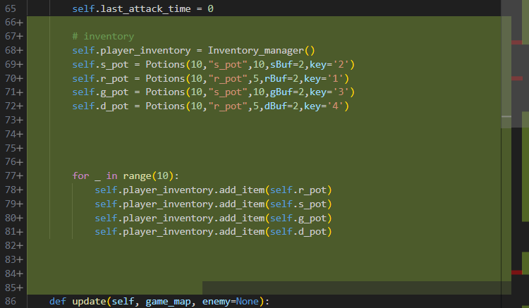  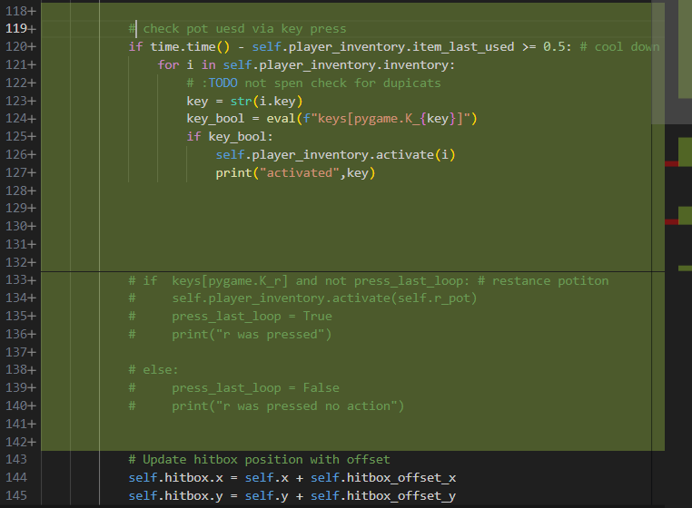

Logbook entry: | - Progress since the last entry:  I have implemented the potions class in the inventory class successfully within the player class. This enables the player to have potions, but I have not yet been able to put the buffs in their spots because I do not know how to do this.  - Tasks achieved:  Enabling potions to be able to be activated with user input but they do not give abilities yet.  - Stumbling blocks or issues encountered and how they were managed:  My biggest stumbling block was getting the potions to be able to be activated by any key. I used “eval()” to accomplish this but I later realised that this was out of the scope of the project because it was unnecessary and I could limit myself to four potions. In addition, it was a security issue.  - Possible approaches for upcoming tasks:  I need to work out a way to change the constant in the game based off which potions are activated from the buff dictionary  - Reflective comments:  The use of eval () and unnecessary scope creep did not help me in this step with the project I need to continue being vigilant for scope creep and help stop it from happening during the development process.  - Resources used:  Kraken desktop for viewing the diffs  Vs code as my IDE  Find (ctrl + F)  Vs code’s linter for help following the code base

Date: | 16/06/2025
Title: | implement buff multipliers correctly
Author: | Git user: “Kings-RIanni” aka Rocco Ianni
Tasks description: | This step is where the buffs dictionary was multiplied with the constants to have the effect of altering the games properties.
Image of the code changed: | 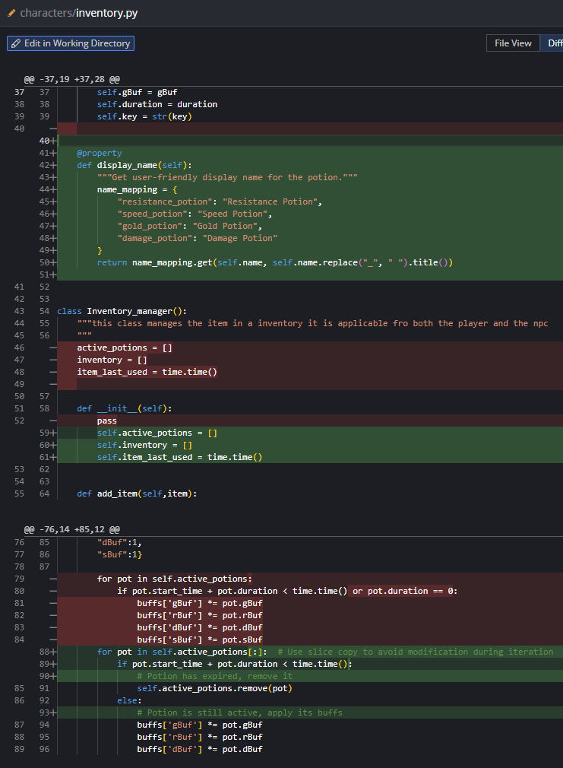  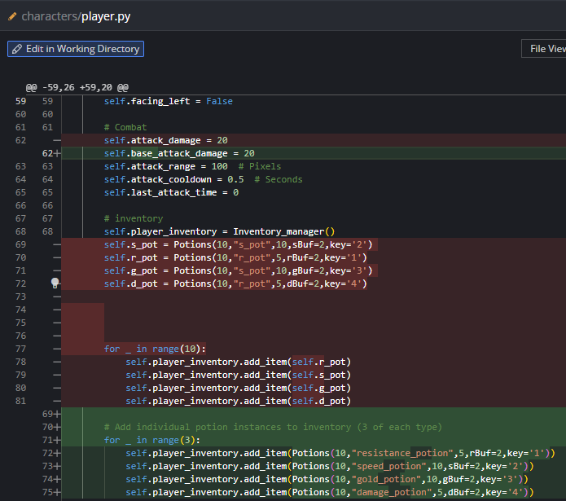  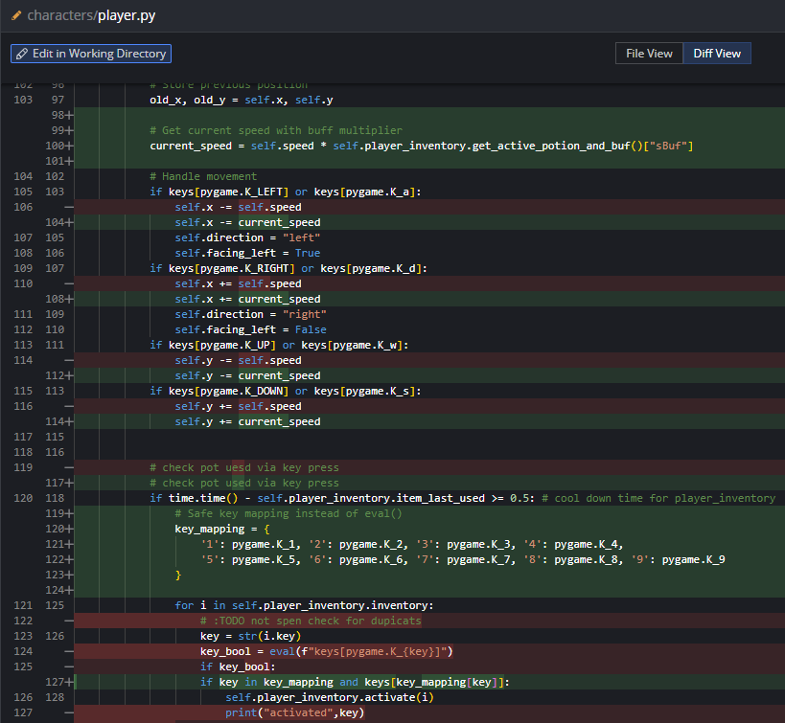  player.py  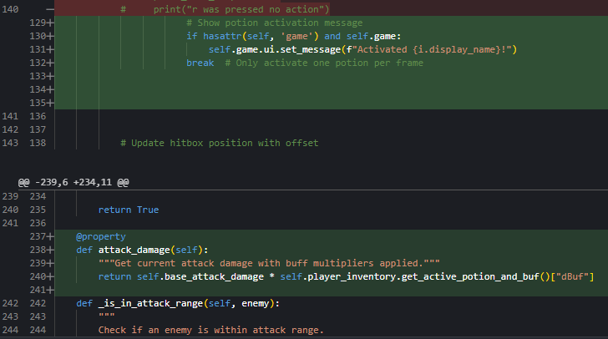  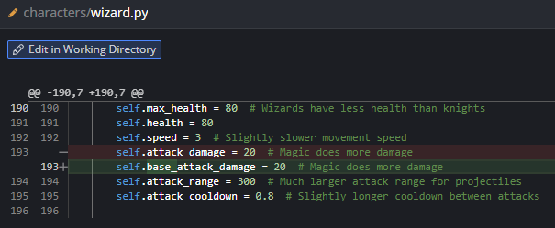  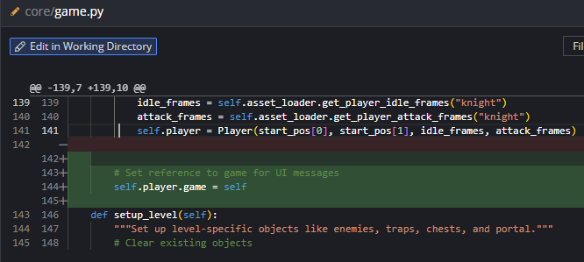  game.py  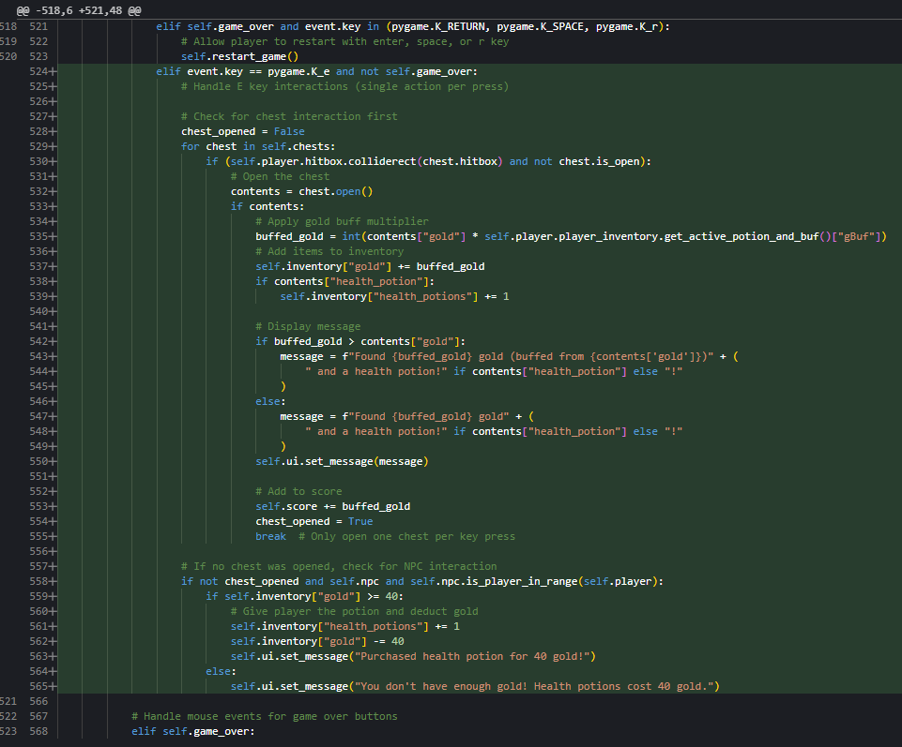  game.py  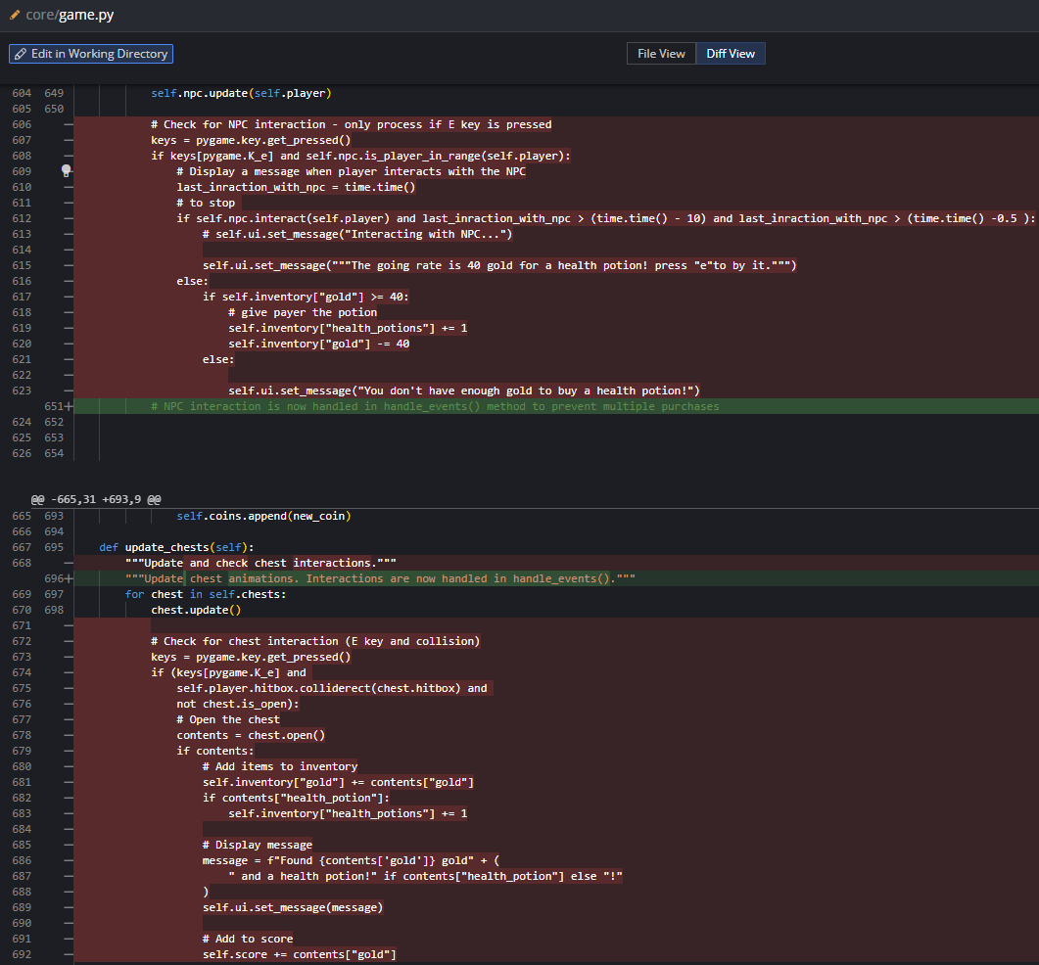  game.py  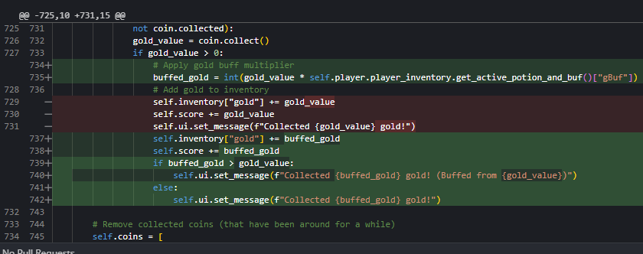  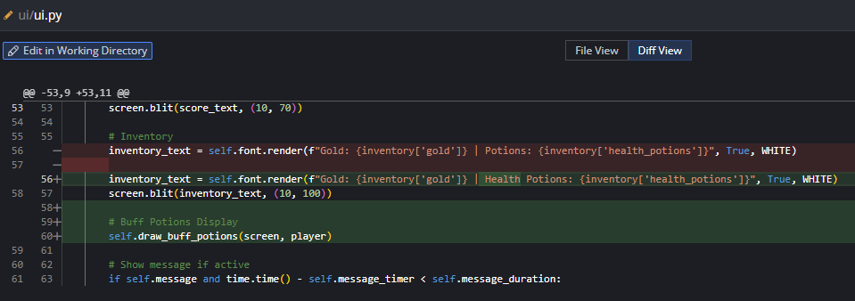  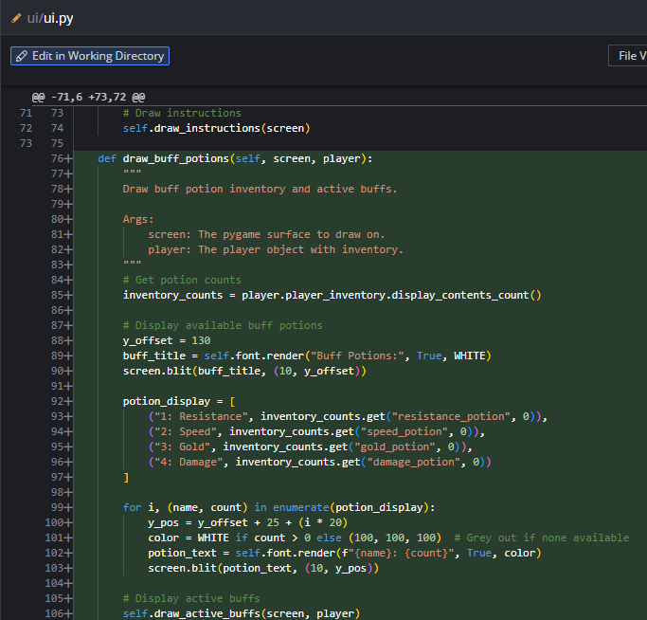  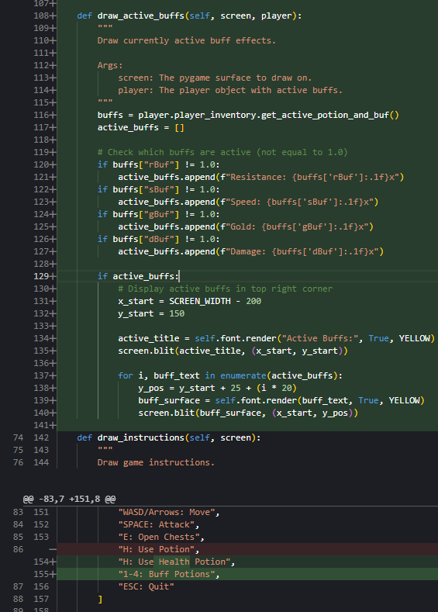  Commit: 12f9bc6c944e8567a644f423d6cf5ef1a5dba5f8

Logbook entry: | - Progress since the last entry:  I have successfully implemented a buff system that works in the game, however the system is still buggy and needs to be fine tuned to optimise user experience during gameplay.  - Tasks achieved:  - Implemented gold buff multiplier  - implemented speed buff multiplier  - implemented resistance buff multiplier  - implemented damage buff multiplier  - Stumbling blocks or issues encountered and how they were managed:  The teacher wrote this code and did not document the stumbling errors, so I can’t discuss issues encountered.  - Possible approaches for upcoming tasks:  The next task I need to complete is to implement a new character. I have chosen to implement the orc as there is already a class there to do this. I need to work out how images are implemented and then I need to override the values from the enemy class to be suited for the orc class.  - Reflective comments:  The way that this was implemented was quite genius because it didn't involve writing that much new code, it simply used the existing code added onto it. which is the benefit of oop.  - Resources used:  Kraken desktop for viewing the diffs  Vs code as my IDE  Find (ctrl + F)  Vs code’s linter for help following the code base

Date: | 18 /06/2025
Title: | fix hitbox bug
Author: | Freddy Gaffey
Tasks description: | The hitbox that was currently implemented was too big and the wrong size for the player, so it needed to be changed to let the player go around corners better.
Image of the code changed: | 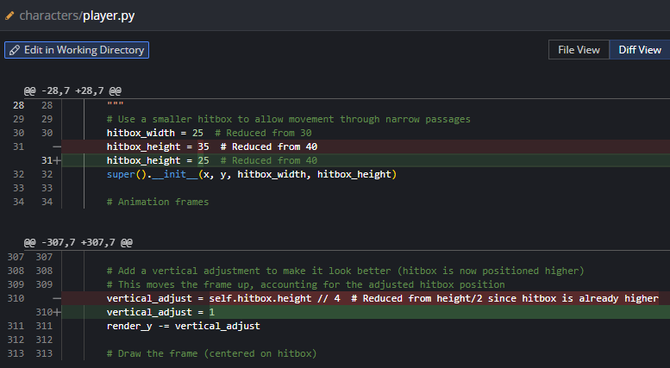  Commit: 7b2ee9860bd520cc88aa07b0f14edd52354384db
Logbook entry: | - Progress since the last entry:  Resolved a small bug  - Tasks achieved:  Resolved the night and that wizard were unable to go around corners well because the hitbox is the same height as the wall width adjusted to fit perfectly.  - Stumbling blocks or issues encountered and how they were managed:  So that I could adjust the hitbox to be the right size I had to get pygame to draw a square around the hip box so that I could dial it in and adjust it until correct.  - Possible approaches for upcoming tasks:  See above  - Reflective comments:  The way I use pygame is to draw a square on the hitbox. The player was very effective and I will remember this trick for future.  - Resources used:  Kraken desktop for viewing the diffs  Vs code as my IDE  Find (ctrl + F)  Vs code’s linter for help following the code base

Date: | 18/06/2025
Title: | implementing potion purchasing of the NPC
Author: | Freddy Gaffey
Tasks description: | Creating default number of potions  Debug the potions activation if statement  Creating NPC purchasing functionality
Image of the code changed: | 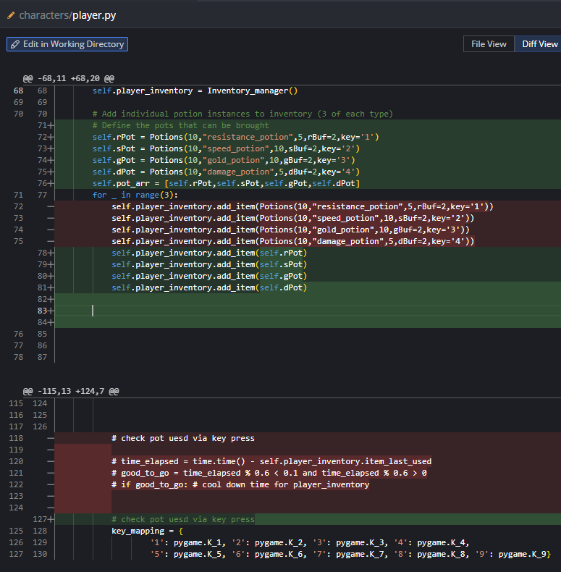  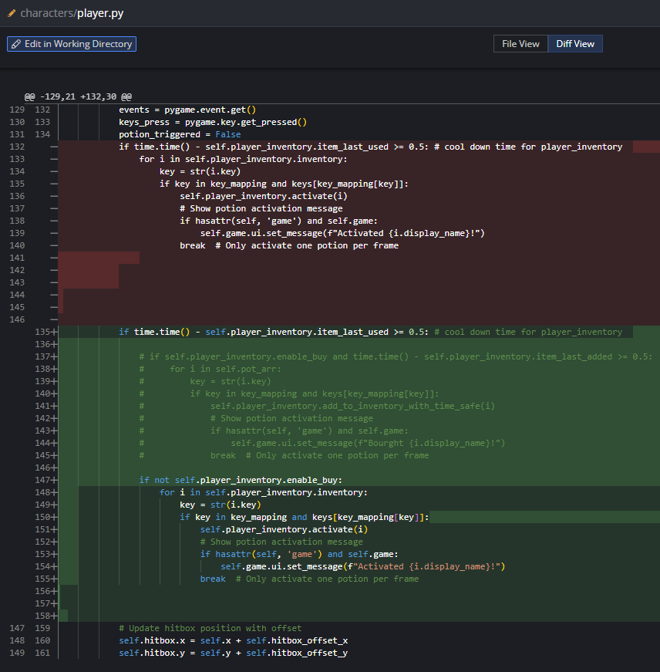  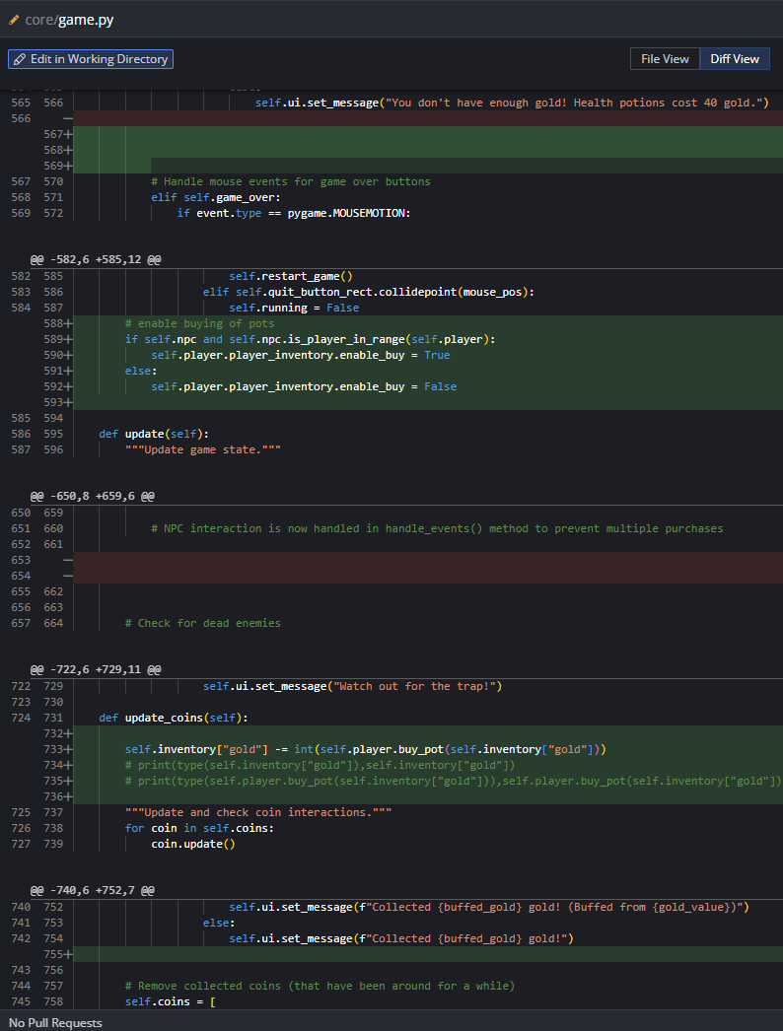  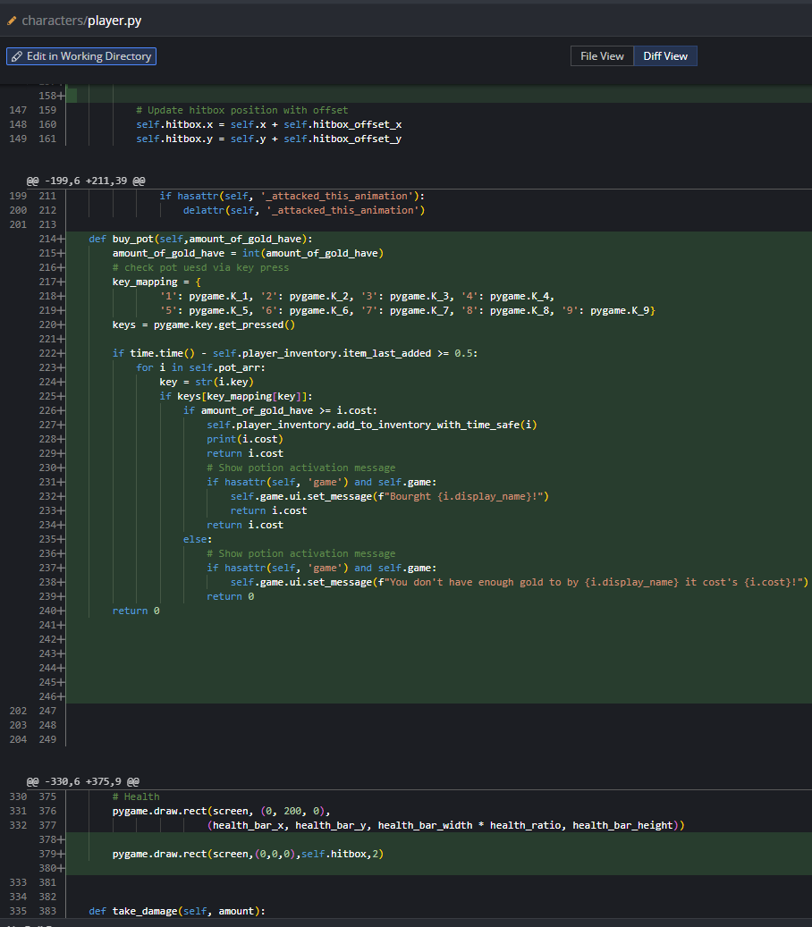  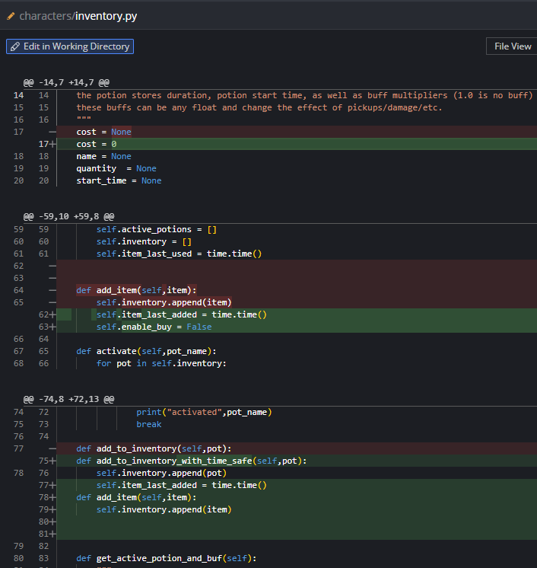  Commit: f7ca652a849fd96168da58fe003819b1003c7627
Logbook entry: | - Progress since the last entry:  Implemented trading and activation successfully of potions, although it is a little buggy .  - Tasks achieved:  Completed the NPC interaction achievement for this assignment but it is still buggy so I need to resolve this.  - Stumbling blocks or issues encountered and how they were managed:  I initially couldn't work out how to enable NPC trading but then I had the idea of checking if in range and using that to send a Boolean value back to the inventory class and this worked well while needing to change minimal technical debt.  - Possible approaches for upcoming tasks:  - Reflective comments:  - Resources used:  Kraken desktop for viewing the diffs  Vs code as my IDE  Find (ctrl + F)  Vs code’s linter for help following the code base

Date: | 22/06/2025
Title: | fix knight one shot kill
Author: | Freddy Gaffey
Tasks description: | I resolved the bug where the night would be able to kill any enemy with one shot no matter how much their health was.
Image of the code changed: | 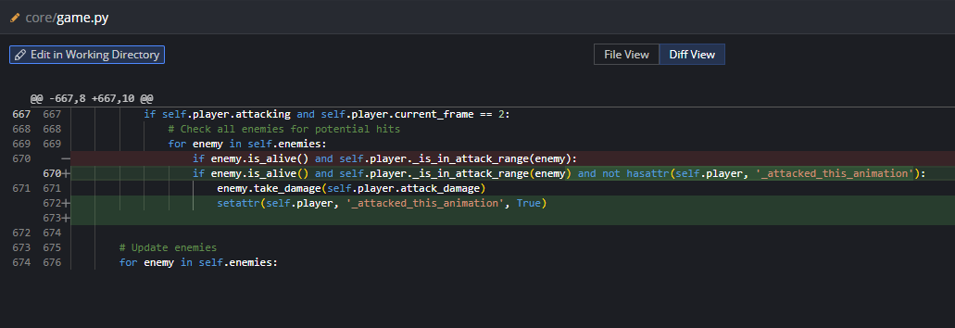  Commit: e1f61540dee0bfb4fd0bf8ba049a63c10f4ef356
Logbook entry: | - Progress since the last entry:  Minor bug fix  I successfully implemented the fix in the ‘if statement’ which let it catch when the play had attacked, resulting in it not doing hits until the enemy died which made the game much more difficult to play and enjoyable.  - Tasks achieved:  Bug fix for Knight one shot kill  - Stumbling blocks or issues encountered and how they were managed:  This solution was difficult to find but when I followed how the wizard did the attack, I realised it was different to how the logic worked, and this let me identify the differences. I also duplicated the wizard's cheques and then I changed them for knight. This was very efficient because it resulted in minimal code changes while solving the issue.  - Possible approaches for upcoming tasks:  Implementing all class through inheritance for the next task.  - Reflective comments:  I use lots of print statements for debugging, as this is what revealed that the for loop was running multiple times each time the enemy attacked because I saw 20/20/20 in the terminal. This combined with me following how the wizard attack worked and then adapting it for the knight to help me identify the bug with minimal backtracking.  - Resources used:  Kraken desktop for viewing the diffs  Vs code as my IDE  Find (ctrl + F)  Vs code’s linter for help following the code base

Date: | 22/06/2025
Title: | Make orc class
Author: | Freddy Gaffey
Tasks description: | Implement Orc functionality but not graphics in an efficient manner
Image of the code changed: | 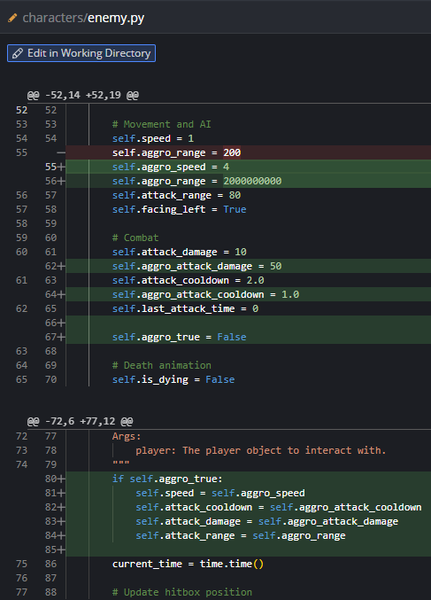  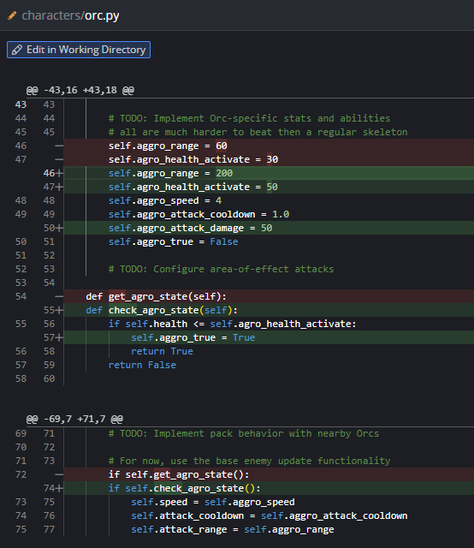  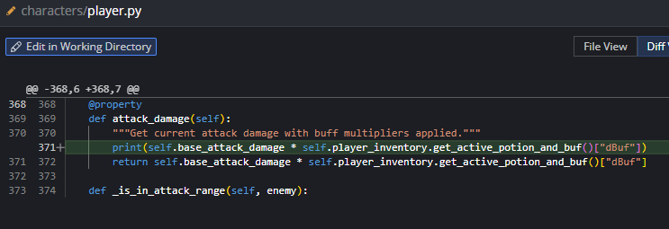  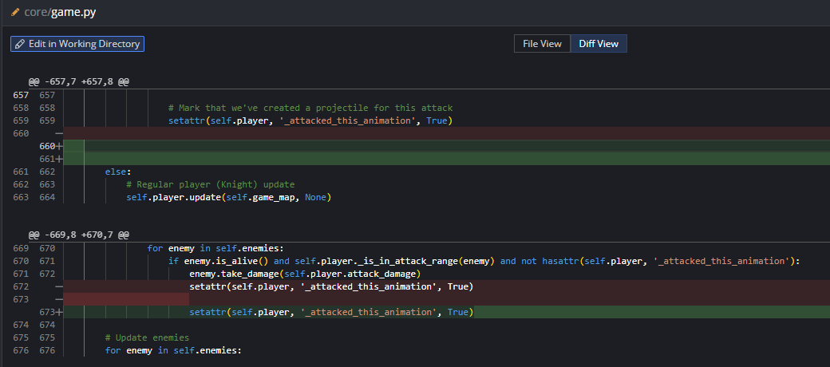  Commit: 2ca5892c948b016e3d7f80be7e6fa92ff68e2a1e
Logbook entry: | - Progress since the last entry:  Using polymorphism, I implemented all the orc class with orc abilities but the graphics have not been implemented yet  - Tasks achieved:  Orc functionality but without the graphics  - Stumbling blocks or issues encountered and how they were managed:  I had some difficulty with getting the rage to work best, so I implemented the rage boost in the enemy class to resolve the inheritance issues and to enable the skeleton to have rage if this was wanted. I implemented a getter in the orc class to return true if the constant needed to be the rage constant.  - Possible approaches for upcoming task:  I will use the sprites, and follow the similar pattern to how the skeleton was implemented, and I will duplicate the same implementation with orcs.  - Reflective comments:  This step went quite smoothly, I was able to leverage the abilities and usefulness of oop to help me write this code efficiently. Another technique I found helpful was the ability to not have to fully implement the feature for an auk. It could be done simply by using the skins and the sprites of the skeleton animations and test if I got the damage functionality working.  - Resources used:  Kraken desktop for viewing the diffs  Vs code as my IDE  Find (ctrl + F)  Vs code’s linter for help following the code base

Rough things to talk about on the video
Video rough script / plan

Npc shop
To create the NPC shop, I first needed to create an inventory. I did this by creating a file inventory.py, and then inside that file I created a class. In the subclass, the class was an Inventory class which had methods that allowed me to add and remove inventory items from the inventory and activate them. I also made a Potions class. This allowed me to have a potion with a predefined template of values such as duration and the spicifc buffs that it would change.
Then I made the on-activation of a potion pop the potion from the inventory to the active potion array. Then I made a loop iterate over the array of objects. Each iteration, it went and got the object's property of duration and start time which let me remove it from a acive potions array.
There is a:
buffs = {
"gBuf": 1,
"rBuf": 1,
"dBuf": 1,
"sBuf": 1
}

Then I found the part of the code where the player had the particular gold buff, speed buff, resistance buff, and damage buff used, and I modified it to multiply it by the respective buff. This let me adjust the character's abilities during gameplay.
Once I had worked out how to implement potions, the next step was to work out how to implement the NPC interaction. To do this, I needed to modify the game loop to return a boolean value to the inventory class. This boolean value dictated whether the NPC was within weapons range of the player. If it was, it disabled the ability to use potions, but on the same button bindings that would typically be used to use the potion, it was assigned to buy a potion from the NPC. This used the add_inventory function. This function is different to just appending to the array because it has a time that it was last used. This limits the speed that you can buy off the NPC, reducing and mitigating spamming and accidentally spending all your money on a particular potion which you did not want.

Orc
The orc worked by using the OOP principle of readability to increase the efficiency and speed of development. How the orc was created is: the parent class Enemy had a collection of variables which could be overwritten, so they were overwritten to adjust the functionality to make a unique enemy. To change the skin colour of the orc from skeleton to orc, the same function that was used to assign the skeleton its skin colour was duplicated and modified to produce a function which would give you the correct sprites for the skin colour change. To enable this to happen, the dictionary at the top of the file asset_loader had to be modified to include an orc. So the skeleton dictionary was copied and renamed to orc. Then the create_orc_skin had to be run. This took me about an hour to figure out that it needs to be run—it was one of those bugs which is so mind-numbingly obvious once you solve them. Then I duplicated the get_enemy_frames function and made another copy of it called get_enemy_orc_frames. This method of doing it has a slight drawback as it increases technical debt, but it is significantly faster than having to work out how to make it in one function enemy_frames. This more general function modification was what I attempted first, but I ended up screwing up the code so badly I had to revert via Git.
To test that the asset loader function was working, I renamed the asset loader function for skeleton to the one for orc and the one for orc to skeleton and ran the code. It successfully changed the appearance of the skeleton to look like orcs. This proved to me that my code modification on the asset loader function was successful and I reverted the name changes.
The next thing I did was modify the game loop to include creation of orcs, so I changed the create_enemy function to have a probabilistic modification which had a choice of creating a certain number of orcs to skeleton ratio. This let me create either orcs or skeletons by using these similar and same methods as a skeleton is created, but I could also create an orc. This led to minimal code alterations, reducing the chances of creating bugs.
Once I had an orc functioning as a skeleton with just different abilities, it was time to create an aggro orc.

Adding an item
To begin this process, I started by looking at what was already there and I found the coin drop. This suited my needs very well because a coin was something that an enemy dropped, and a lot of the existing infrastructure was already there for only dropping one upon death of the enemy.
So what I did was I modified the Enemy class to include an enemy_type. This let me do an if statement in the place where the gold coin was created to determine whether or not it would also drop an orc drop. This is an item which levels up the player either through a magician path if it is a wizard or a knight path if it's a knight.
The implementation of this levelling up is done through the buff system which was created for the potion implementation. It adds the orc drop to the inventory of the player then activates it. This orc drop has its properties for the particular amount of improvements that it gives, but it also does specific improvements depending on the keypress. So it will either put your player in a powerful defensive mode or an offensive mode…

VOICE TO TEXT DUMP
Npc shop
To create the MPC shop I first need to create an inventory I did this by creating a file inventory dot PY and then create inside that file I created a class in the subclass the class was a inventory class which had methods that allowed me to add and remove inventory items from the imagery and activate them. I also made a potions class this allowed me to have a potion with predefined template of values such as duration and which particular buffs it would change.

Then I made the on activation of potion pop the potion from inventory 2 the active potion array then I made a loop iterate over the array of objects each iteration it went and got the objects property of duration and start time which was modified when the object was activated. The loop got the summation of the buffs

there is a:
buffs = {
"gBuf":1,
"rBuf":1,
"dBuf":1,
"sBuf":1}

Then I found the part of the code where the player had the particular gold buffs paid buff resistance buff damage buff used and I modified it to multiply it by the respective buf this let me adjust the characters abilities during gameplay

once I had worked out how to implement potion it was the next step to workout how to implement the NBC interaction to do this I needed to modify the game loop to return a boolean value to the inventory class this boolean back value dictated whether the NPC was within weapons range of the player if it was it disabled the ability to use potions but on the same button bindings that would typically be used to use the potion it was assigned to by a potion from the NPC and this used the ad inventory function this function is different to just depending to the array because it has a time that it was last used this limits the speed that you can buy off the NBC reducing and mitigating spamming and accidentally spending all your money on a particular potion which he did not want

Orc
The awk worked by using the oop principle of readability to increase the efficiency and speed of development. How the orc was created is the parent class enemy had a collection of variables which could be overwritten so they were overwritten to adjust the functionality to make a unique enemy. To change the skin colour of the ork from skeleton to orc the same function that was used to assign this skeleton its skin colour was duplicated and modified to produce a function which would give you the correct sprites for the skin colour change to enable this to happen the dictionary at the top of the file asset loader had to be modified to include a orc so the skeleton dictionary was copied and renamed to orc. Then the create or skin had to be ran this took me about an hour to figure out that it needs to be ran it was one of those bugs which is so mind numbingly obvious once you solve them. Then I duplicated the get enemy frames function and made another copy of it called get enemy orc frames this method of doing it has a slight drawback as it increases technical debt but it is significantly faster than having to workout how to make it in one function enemy frames this more general function modification was what I attempted first but I ended up screwing up the code so badly I had to revert by via git.

To test that the asset loader function was working I renamed the asset loader function for skeleton to the one for orc and the one for orc for skeleton and ran the code and it successfully changed the appearance of the skeleton to look like Hawks this proved to me that my code modification on the asset loader function was successful and I reverted the name changes.

The next thing I did was I needed to modify the game loop to include creation of books so I changed the create enemy function too have a probabilistic modification which had a choice of creating a certain number of orcs to skeleton ratio. This let me create either orcs or skeletons by using these similar and same methods as a skeleton is created but I could also create an awk this led to minimal code alterations reducing the chances of creating bugs.

Once I had a walk functioning as a skeleton with just different abilities it was time to create an aggro's orc.
Adding a item
To begin this process I started by looking at what was already there and I found the coin drop this suited my needs very well because a coin was something that an enemy dropped and a lot of the existing infrastructure was already there for only dropping one upon death over the enemy

So what I did was I modified the enemy clause to include a enemy type this let me do an if statement in the place where the gold coin was created to determine whether or not it would also drop a orc drop this is a item which levels up the player either through a magician path if it is a wizard or a night path if it's a knight

the implementation of this levelling up is done through the buff system which was created for the potion implementation is it adds the walk drop to the inventory of the player then activates it this awk drop has its properties for the particular amount of improvements that it gives but it also does specific improvements depending on the keypress so it'll either put your play in a powerful defensive mode or an offensive mod

